Interagency Committee on Disability Research

Government-Wide Strategic Plan Development Process

Fiscal Years 2017-2020

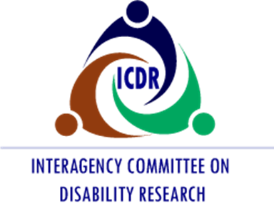

Robert Jaeger, ICDR Designated Chair and Director,
National Institute on Disability, Independent Living, and Rehabilitation Research (NIDILRR)

icdr.acl.gov

This document was produced by New Editions Consulting, Inc. under U.S. Department of Health and Human Services (HHS), Administration for Community Living (ACL) Contract No. ED-OSE-12-C-0054 on behalf of the Interagency Committee on Disability Research (ICDR). Maggie Hatton served as the Contracting Officer’s Representative. The views expressed herein do not necessarily represent the positions or policies of the ICDR or the Federal Government. No official endorsement by the ICDR of any product, commodity, services, or enterprise mentioned in this publication is intended or should be inferred. Inquiries can be sent to ICDRinfo@neweditions.net.

Guiding Principles for Success
As a first step in developing this plan, the ICDR, with the assistance of an outside facilitator, developed guiding principles to clarify its role and purpose. These principles also serve as guideposts in the plan development process.
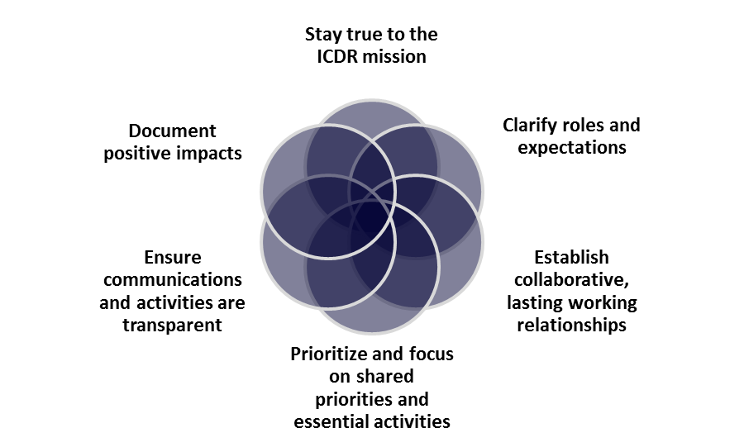
Figure 1. ICDR Guiding Principles
- Stay true to the ICDR mission. The committee should identify its unique niche in disability, rehabilitation, and independent living research, and ensure that its efforts benefit its many stakeholders and partners. Initiatives should focus on the interagency nature of the ICDR and complement the work that agencies are already doing. Establishing a consistent, trusted brand would help achieve its mission.
- Clarify roles and expectations. Clearly established expectations are needed for each agency partner to ensure buy-in and support. As the ICDR pursues its collective work, it must consider and respect the diversity of agencies’ missions, perspectives, priorities, and decisions. Agencies should be accountable for fulfilling their roles. Committee members should be clear on what decisions they are empowered to make and share that information with fellow members.
- Establish collaborative, lasting working relationships. Committee members must trust their partners for mutual efforts to be most effective. Commitment to the ICDR’s mission is critical and membership can be encouraged and supported by actively soliciting diverse perspectives, positions, and opinions.
- Prioritize and focus on shared priorities and essential activities. Identifying realistic and meaningful activities will help develop common ground among members, capitalize on existing capabilities, and leverage resources. This will assist in decision-making about what can be realistically accomplished with the time and resources available.
- Ensure communications and activities are transparent. Communication should be open and regular among committee members and across agencies. ICDR goals, strategies, and activities should be transparent with agency contributions openly recognized.
- Document positive impacts. Success will be determined by measuring the positive impacts that disability research and collaboration have on the disability community. The ICDR should pursue clearly defined goals that are compelling and meaningful to member agencies, demonstrate accountability, and share concrete outcomes.

Relevance
According to the Centers for Disease Control and Prevention, over 22 percent of Americans experience a disability and that number is expected to increase markedly with the aging of baby boomers. People with disabilities experience significant disadvantages—lower employment rates and annual earnings; lower educational attainment; inadequate access to housing, transportation, technology, and health-care; and greater likelihood of living in poverty. The rate of disability is higher for individuals who are American Indian/Alaska Native and African American than for those who are white. The need for disability research that can help improve the quality of life of all people with disabilities is pressing.
The Institute of Medicine (IOM) broadly defined disability-related research to encompass:
Research with the ultimate goals of restoring functioning, maintaining health and preventing secondary conditions, and understanding the factors that contribute to impairments, activity limitations, and participation restrictions. This research takes many forms, including classical clinical trials, observational and epidemiological studies, engineering research, health services research, survey, research on many topics, other kinds of social science and behavioral studies, the development of measures and research tools, and research training and other capacity-building activities.
Disability research can be life changing for people with disabilities. The IOM stressed the value of research to clinicians, public agencies, private organizations, families, and individuals with disabilities. Results of such research can inform decision-making and choices that promote independence, productivity, and community participation.

Barriers and Opportunities
In 2014, the ICDR convened an Expert Panel to review research and experiential knowledge related to interagency collaboration in order to identify strategies for promoting and sustaining interagency collaboration and partnerships in disability research. The panel identified barriers to disability research collaboration that may affect the success of this plan including:
- Limited success in engaging active participation by key Federal statutory members;
- The need for a stronger foundation for Federal agencies to share information and collaborate on disability research;
- A lack of funding to support disability research and the infrastructure and initiatives of the ICDR;
- Ability to balance the broad scope of the ICDR with the need to be pragmatic in what can be successfully accomplished; and
- The need to engage more stakeholders in the ICDR and disability research.
The Expert Panel findings echo observations made by the Institute of Medicine (IOM) in its 2007 report The Future of Disability in America. The report indicated that ICDR was helpful as an information conduit for agencies to learn about research activities throughout the government and areas of mutual interest. However, a major inhibitor to greater effectiveness was that the ICDR “lacks the authority or incentives to command or entice attention and cooperation from powerful agencies such as NIH and VA” (p. 111-112).
Recognizing these long-standing barriers, the ICDR decided to capitalize on synergies and opportunities to collaborate when developing this government-wide strategic plan including:
- Leveraging efforts and resources between the government-wide strategic plan and other related Federal initiatives, advisory committees, and planning efforts. Examples include the National Institutes of Health Medical Rehabilitation Coordinating Committee (that authored the NIH Rehabilitation Research Plan), the Interagency Autism Coordinating Committee, the Federal Interagency Traumatic Brain Injury Research information system, the Interagency Pain Research Coordinating Committee, the President’s Committee for People with Intellectual Disabilities, the Interagency Collaborative to Advance Research in Epilepsy, and others.
- Capitalizing on the opportunity created by the requirement for the GWI to harmonize understanding and definitions among agencies about what disability, independent living, and rehabilitation research includes. The ICDR needs to consider the differing needs of people with intellectual, social, sensory, physical, and psychiatric disabilities. In addition, some individuals, such as people with autism and cerebral palsy need habilitative services to gain functioning. These discussions will be important, not only as the ICDR considers its scope of research, but also in designing the GWI.
- Utilizing a broad stakeholder process to hone in on a pragmatic focus on a few crosscutting areas that are achievable and of mutual interest to multiple Federal agencies.

Strategic Planning Process
The ICDR embarked on a yearlong planning process to develop the strategic plan. The ICDR Executive Committee (EC), composed of 17 statutory member agencies and invited agency representatives, served as the decision-making body for the strategic planning process. One of the first activities, and a part of the mandated activities required by WIOA, was to set the vision and guiding principles for success. The EC decided to concentrate on the interagency nature of the ICDR and focus on areas that complement what agencies are already doing, while being responsive to priorities in the research and disability communities.
The charge to develop this plan is complex and multi-faceted. Some of its mandated components are discreet tasks that have been successfully completed. Others will require the prioritization of multiple agency partners and significant resources, both human and financial. These, and other challenges, have historically been identified when attempting to unify government investments and priorities related to disability, independent living, and rehabilitation research.
The strategic plan also builds upon previous efforts to promote interagency collaboration and increase the impact of the ICDR. These efforts include:
- Focused efforts in Fiscal Years (FYs) 2013-2014 to increase Federal agency awareness of disability and rehabilitation research and related activities across the Federal government. The partnership meetings highlighted the need for the ICDR to facilitate connections and partnerships between Federal agencies and across the disability and rehabilitation research community.
- Creating a Sustainable Interagency Coordination Network on Disability Research: Report of the Expert Panel includes findings and recommendations of an ICDR Expert Panel that met in FY 2014 to identify the state of the science related to interagency collaboration and suggest steps toward creating a sustainable interagency coordination network around disability research.
- Primer on Interagency Research Collaboration serves as a reference guide that includes an overview of best practices to foster interagency collaboration based on an ICDR literature review, documents from other interagency research efforts, and the ICDR expert panel report.
After considering the recommendations and lessons learned, the ICDR reviewed other Federal strategic planning efforts. The EC adopted the process they would use to develop the government-wide strategic plan in August 2015.

Working Groups
Five topical working groups of the ICDR convened to define critical research problems that included more than 100 representatives of Federal, research, service provider, and advocacy organizations. According to the WIOA charge, the key content areas for the ICDR to address include assistive technology (AT) and universal design (UD), education, employment, health, rehabilitation, wellness, independent living, and community integration and participation. Five working groups addressed these topics and generated a list of research gaps and opportunities. They refined those suggestions into topics, and solicited further stakeholder input to articulate priorities and recommendations that include underemphasized areas of research. This information informed strategic planning deliberations.
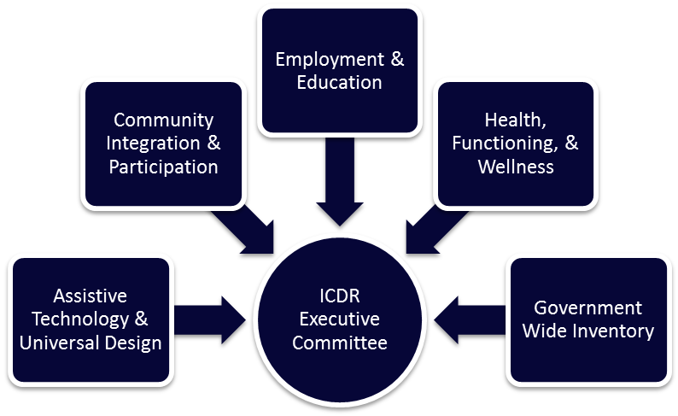

Figure 2: ICDR Working Groups

- The Assistive Technology and Universal Design (AT/UD) working group scope includes research, design, development, policy, systems, and services related to AT, accessibility of electronic information and technology, products, and environments.
- The Community Integration and Participation (CIP) working group scope includes research, policy, systems, and services related to behavioral, social, and environmental factors affecting inclusion in society.
- The Employment and Education (EE) working group scope includes research, policy, systems, and services related to employment and self-sufficiency of people with disabilities, and youth transition to employment, post-secondary education, and community life.
- The Government-Wide Inventory (GWI) working group is charged with developing the WIOA-mandated GWI of disability, independent living, and rehabilitation research.
- The Health, Functioning, and Wellness (HFW) working group scope includes research, clinical, translational, policy, systems, and services related to medical rehabilitation, prevention, health and wellness care, public health issues, and surveillance. This group initially focused primarily on health and wellness. An additional medical rehabilitation research stakeholder input session suggested the addition of “functioning” to the title of this working group.

Stakeholder Input
Stakeholders were involved in the strategic planning process from the start. Consistent with WIOA, stakeholders include:
- Policymakers
- Representatives from other Federal agencies conducting relevant research
- Individuals with disabilities
- Organizations representing individuals with disabilities
- Researchers
- Providers
Stakeholders were actively engaged in the working groups. Additionally, the ICDR held two stakeholder webinars in November 2015 to encourage further stakeholder input. A second stakeholder webinar in March 2016, welcomed stakeholder review and comment on the strategic plan framework and cross-cutting themes. After receiving this stakeholder input, the ICDR held three more meetings to obtain additional stakeholder input on the medical rehabilitation aspects of disability, independent living, and rehabilitation research.
Although this strategic plan does specifically identify underemphasized areas of research as required by WIOA in the comprehensive plan, stakeholders identified over 200 research ideas during the stakeholder process. A supplemental document, Working Group Research Gaps, Problem Statements, and Final Priorities contains the full set of stakeholder ideas and working documents generated in the strategic plan development process.

Centers for Disease Control and Prevention. July 31, 2015. Morbidity and Mortality Weekly Report, Prevalence of Disability and Disability Type Among Adults — United States, 2013. 64(29), 777-783. Available at: http://www.cdc.gov/mmwr/preview/mmwrhtml/mm6429a2.htm
National Council on Disability. October 2011. National Disability Policy: A Progress Report. Available at: http://www.ncd.gov/progress_reports/Oct312011.
Centers for Disease Control and Prevention. October 7, 2011. Morbidity and Mortality Weekly Report, QuickStats: Percentage of Adults Aged ≥18 Years with a Complex Activity Limitation, by Race/Ethnicity --- National Health Interview Survey, United States, 2003—2009. 60(39), 1361. Available at: http://www.cdc.gov/mmwr/preview/mmwrhtml/mm6039a9.htm?s_cid=mm6039a9_w.
Institute of Medicine. (2007). The Future of Disabilty in America. Washington, DC: The National Academy Press
Ibid

