Interagency Committee on Disability Research: FY 2020 Accomplishments

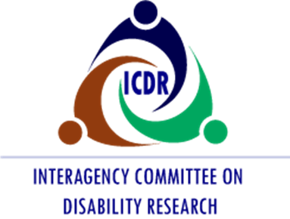

This report was produced by New Editions Consulting, Inc., under U.S. Department of Health and Human Services (HHS), Administration for Community Living (ACL), Contract No. GS-00F-0083N on behalf of the Interagency Committee on Disability Research (ICDR). Maggie Hatton served as the Contracting Officer’s Representative. The views expressed herein do not necessarily represent the positions or policies of the U.S. Department of Health and Human Services. No official endorsement by the U.S. Department of Health and Human Services of any product, commodity, service, or enterprise mentioned in this publication is intended or should be inferred.
U.S. Department of Health and Human Services
Norris Cochran
Acting Secretary
Administration for Community Living
Alison Barkoff
Acting Administrator and Assistant Secretary for Aging
National Institute on Disability, Independent Living, and Rehabilitation Research
Dr. Kristi Hill
Acting Director
March 2021
This report is in the public domain. Authorization to reproduce it in whole or in part is granted. While permission to reprint this publication is not necessary, the citation should be:
Interagency Committee on Disability Research. (2021). The Interagency Committee on Disability Research: FY 2020 Accomplishments. Washington, D.C.
This report is available on the ICDR’s website at http://www.icdr.acl.gov

Introduction

Overview
This accomplishments report details the fiscal year (FY) accomplishments and activities of the Interagency Committee on Disability Research (ICDR). During the first part of FY 2020, the ICDR focused on making enhancements to its website to increase collaboration among its member agencies. In addition, the ICDR devoted much of its efforts to the final development of a searchable Government Wide Inventory of Disability, Independent Living, and Rehabilitation Research, set to launch in early FY 2021. Efforts to implement the government-wide strategic plan continued, as well as ongoing activities to support the ICDR’s overall mission, goals, and objectives. In FY 2020, the ICDR shared COVID-19 and disability resources, held four EC meetings, and produced several new interagency resources.

Mission
The ICDR is a coordinating group of federal department and agency representatives funding disability, independent living, and rehabilitation research. Authorized by the 1973 Rehabilitation Act, as amended by the Workforce Innovation and Opportunity Act (WIOA), the ICDR promotes coordination and cooperation among federal departments and agencies conducting disability, independent living, and rehabilitation research programs, including programs relating to assistive technology (AT) research and research that incorporates the principles of universal design. The ICDR charge is to:
- Identify, assess, and seek to coordinate all federal programs, activities, and projects and plans for such programs, activities, and projects with respect to the conduct of research (including AT research and research that incorporates the principles of universal design) related to independent living;
- Obtain input from policymakers, representatives from federal agencies, individuals with disabilities, organizations representing individuals with disabilities, researchers, and providers;
- Share information about research being carried out by members of the committee and other federal departments and organizations;
- Identify and make efforts to address areas of research that are not being adequately addressed;
- Identify and establish clear research priorities;
- Promote interagency collaboration and joint research activities and reduce unnecessary duplication of effort;
- Optimize the productivity of ICDR members through resource-sharing and other cost sharing activities; and
- Develop a comprehensive government-wide strategic plan for disability, independent living, and rehabilitation research.

ICDR Membership
The ICDR develops its agenda and establishes goals and objectives through an interagency Executive Committee (EC). The EC is comprised of 17 ICDR statutory member agencies, the ICDR standing committee co-chairs, and other designated agency representatives. In carrying out its duties, the EC:
- Sets the ICDR agenda;
- Works to promote effective interagency coordination, collaboration, and communication;
- Provides guidance to the ICDR committees;
- Reviews and approves committee plans;
- Secures the input of other federal agencies and stakeholders;
- Develops the ICDR strategic plan; and
- Hosts meetings to advance the agenda of federal departments, offices, and partner agencies.
ICDR statutory members include: Secretary, Health and Human Services; Director, National Institute on Disability, Independent Living, and Rehabilitation Research (Designated Chair); Commissioner, Rehabilitation Services Administration; Assistant Secretary, Special Education and Rehabilitative Services; Assistant Secretary, Labor for Disability Employment Policy; Secretary, Defense; Administrator, Administration for Community Living; Secretary, Education; Secretary, Veterans Affairs; Director, National Institutes of Health; Director, National Institute of Mental Health; Administrator, National Aeronautics and Space Administration; Secretary, Transportation; Assistant Secretary, Interior for Indian Affairs; Director, Indian Health Service; Director, National Science Foundation; and Administrator, Small Business Administration

Guiding Principles of the ICDR
The ICDR vision is to be widely recognized for facilitating and coordinating federal interagency efforts and for promoting collaborative relationships that maximize the best use of federal resources for disability, independent living, and rehabilitation research. To meet these goals, the ICDR identified six guiding principles:
1. Stay true to the ICDR mission. The committee should identify its unique niche in disability and independent living research and ensure that its efforts benefit its many stakeholders and partners. Initiatives should focus on the interagency nature of the ICDR and complement the work that agencies are already doing. Establishing a consistent, trusted brand would help the ICDR achieve its mission.
2. Clarify roles and expectations. To ensure buy-in and support from each partner agency, the ICDR must clearly establish its expectations. As the ICDR pursues its collective work, it must consider and respect the diversity of agency missions, perspectives, priorities, and decisions. Agencies should be accountable for fulfilling their roles. Committee members should be clear on what decisions they are empowered to make and share that information with fellow members.
3. Establish collaborative, lasting working relationships. Committee members must trust their partners for mutual efforts to be most effective. Commitment to ICDR’s mission is critical, and membership can be encouraged and supported by actively soliciting diverse perspectives, positions, and opinions.
4. Prioritize and focus on shared priorities and essential activities. Identifying realistic and meaningful activities will help develop common ground among members, capitalize on existing capabilities, and leverage resources. This will assist in decision-making about what the ICDR can realistically accomplish with the time and resources available.
5. Ensure communications and activities are transparent. Communication should be open and regular among committee members and across agencies. The ICDR’s goals, strategies, and activities should be transparent, with agency contributions openly recognized.
6. Document positive impacts. Success will be determined by measuring the positive impacts that disability research and collaboration have on the disability community. The ICDR should pursue clearly defined goals that are compelling and meaningful to member agencies, demonstrate accountability, and share concrete outcomes.
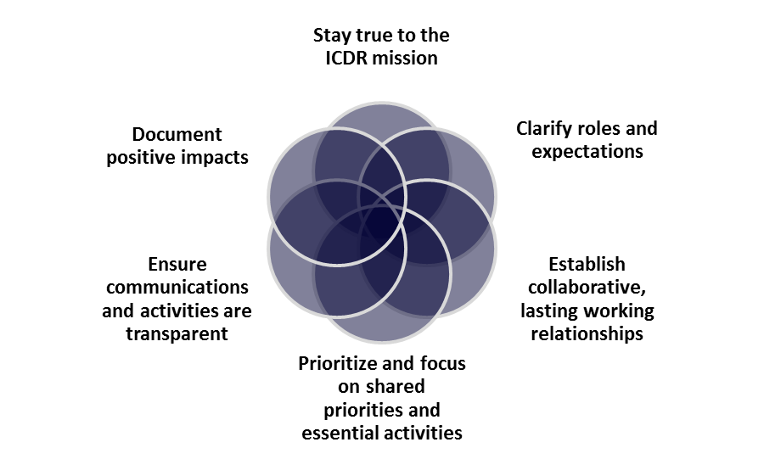
Figure 1: ICDR Guiding Principles
To ensure adequate attention to the interest of individuals with disabilities, the ICDR partners with a variety of agencies. Participants contribute their knowledge and expertise to working groups and conference-planning committees; collect data; make recommendations on research priorities; and disseminate information. These activities stimulate thinking about research-based solutions to issues confronting federal agencies.

ICDR Working Groups
The ICDR niche is broad. It includes all types of research addressing physical and mental function, rehabilitative services and technology, social and community integration, and independent living, as well as all types of disabilities and chronic conditions. There are five ICDR working groups. Some federal partners play key leadership roles on the ICDR by serving as co-chairs for standing workgroups, providing co-funding for specific activities, and providing resources to help the ICDR achieve its goals.
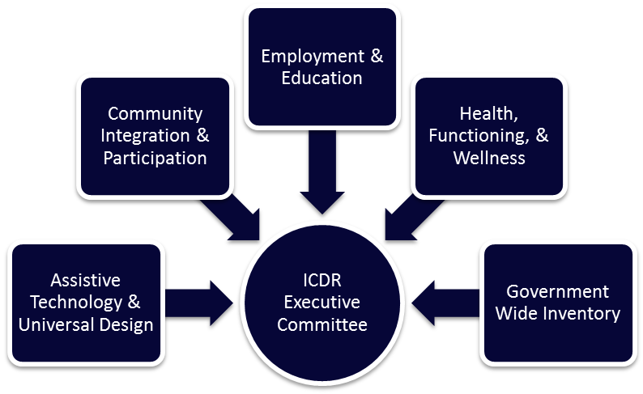
Figure 2: ICDR Working Groups
- The Assistive Technology and Universal Design (AT/UD) working group scope includes research, design, development, policy, systems, and services related to AT and accessibility of electronic information and technology, products, and environments.
- The Community Integration and Participation (CIP) working group scope includes research, policy, systems, and services related to behavioral, social, and environmental factors affecting inclusion in society.
- The Employment and Education (EE) working group scope includes research, policy, systems, and services related to employment and self-sufficiency of people with disabilities, as well as youth transition to employment, postsecondary education, and community life.
- The Health, Functioning, and Wellness (HFW) working group scope includes research, clinical, translational, policy, systems, and services related to medical rehabilitation, prevention, health and wellness care, public health issues, and surveillance, among others. This group focuses primarily on health and wellness. An additional stakeholder input session suggested the addition of “functioning” to the title of this working group.
- The Government Wide Inventory (GWI) working group is charged with developing the WIOA-mandated GWI of disability, independent living, and rehabilitation research.

During FY 2020, the ICDR focused on promoting and optimizing interagency coordination and collaboration through its activities and resulting recommendations. The ICDR EC and working groups met throughout FY 2020 to implement their strategic work plans and discuss current and emerging research areas of interest to the ICDR. Topic areas discussed in FY 2020 included:
- Impact of COVID-19 on agency’s operations, research, funding opportunities, and programs;
- Impact of COVID-19 on people with disabilities, providers, and researchers, as well as the broader impact on the field of disability, independent living, and rehabilitation research;
- Development of a housing research portfolio and federal housing resources for people with disabilities;
- Employment and transition strategies, services, supports, and resources for youth with disabilities amid crisis;
- Strategies to include people with disabilities in federal research; and
- Inclusion strategies for health and wellness programs.

Highlighted Activities of the ICDR
In FY 2020, the ICDR continued with the ongoing work of its mission. The ICDR devoted much of its efforts to the implementation of the government-wide strategic plan required by WIOA. The ICDR hosted meetings related to activities of the government-wide strategic plan during FY 2020 to promote coordination, collaboration, and partnerships. In addition to the implementation of strategic plan activities, the ICDR continued its ongoing activities to support its overall mission, goals, and objectives.

Highlighted Activities
- Sharing resources related to COVID-19 and disability.
- Continued development and maintenance of the Government Wide Inventory of Disability, Independent Living, and Rehabilitation Research.
- Publishing resources on the issues of housing, independent living, and health, functioning and wellness for members and stakeholders.
- Publishing a white paper and timeline on the historical significance of the ICDR and its contributions to the field of disability, independent living, and rehabilitation research.
- Continuing to enhance and expand the functionality of the ICDR Website to ensure transparency and public access to news, research, funding opportunities, events, and resources in the field of disability, independent living, and rehabilitation research.
- Supporting continued collaboration among ICDR member agencies and partners by hosting four EC meetings.
- Planning for additional toolkits, a white paper, and a Transition Symposium in FY 2021.

COVID-19 Resources from ICDR Member Agencies
The COVID-19 pandemic has had a dramatic effect on the lives of people with disabilities, as well as disability research conducted across ICDR member agencies. New topics and concerns have emerged in the disability research sphere as a result of COVID-19. Some of the emerging topics include: the direct service professional workforce, health care rationing, effect of COVID-19 on preexisting health disparities, increased susceptibility of people with disabilities to COVID-19, unemployment, pandemic-related stress and trauma, and the shift to virtual services and supports.
Disability research has expanded its scope in creative ways to examine COVID-19 and disability, yet several areas still remain largely unaddressed. The following themes emerged as concerns for the ICDR that warrant further research: (1) the impact of the transition to reliance on technology and virtual services and supports for people with disabilities, (2) the economic impact of COVID-19 on people with disabilities, (3) inclusion of people with disabilities in current emergency planning systems, and (4) the impact of COVID-19 on social isolation for people with disabilities.
ICDR member agencies shared their resources related to COVID-19 and disability in FY 2020:
- The National Institute of Mental Health (NIMH), Interagency Autism Coordinating Committee (IACC) has created a webpage specific to COVID-19 that includes federal resources and general information in an effort to link resources related to disability and autism: https://iacc.hhs.gov/resources/coronavirus/.
- The Administration for Community Living (ACL) has a webpage of resources for older adults and people with disabilities around COVID-19: https://acl.gov/COVID-19.
- Rehabilitation Services Administration (RSA) has a number of resources that offer guidance related to COVID-19. These include a variety of Q&A resources related to topics like vocational rehabilitation services and fiscal management of VR program. The resources can be found on https://www.ed.gov/coronavirus.

Searchable Government Wide Inventory of Disability, Independent Living, and Rehabilitation Research
WIOA requires the ICDR to develop and maintain a searchable GWI of disability, independent living, and rehabilitation research for trend and data analysis across federal agencies. The GWI working group previously identified the National Institutes of Health (NIH) Library within the Office of Research Services as a resource for this task. The NIH Library has robust capabilities in creating research portfolios and was suitable for the ICDR’s needs. The NIH Library takes Federal RePORTER data and pulls information based on matched terms to create portfolio analyses. The Federal RePORTER serves as a repository of data and tools to assess the impact of federal research and development investments. The National Institute of Neurological Disorders and Stroke, National Center for Medical Rehabilitation Research, and the National Institute on Disability, Independent Living, and Rehabilitation Research (NIDILRR) committed funds to this project.
During FY 2020, the working group met regularly with interagency colleagues to continue development of the GWI. The GWI group worked with the NIH Library to curate datasets from multiple agencies into one dataset. A test platform was developed and organizational data have been populated. The group introduced FY 2016 and 2017 data into the system. The current version of the GWI will include data from NIDILRR and NIH. They are expected to also include data from Veterans Affairs, National Science Foundation, the Centers for Disease Control and Prevention, and the Department of Defense. NIDILRR, the National Institute of Child Health and Human Development, and the National Center for Medical Rehabilitation Research are currently working to schedule a launch date that is expected for FY 2021.
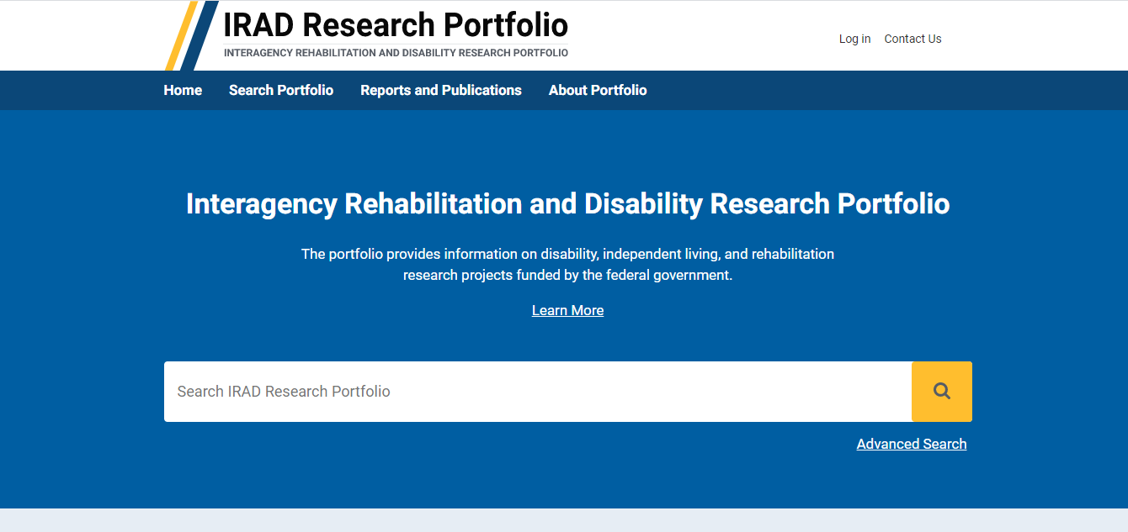

New Interagency Resources

Federal Housing Resources for People with Disabilities: A Toolkit for Interagency Collaboration
The ICDR Housing Toolkit provides resources to facilitate further federally-funded research in the area of housing and to foster interagency collaboration in the field of housing resources for people with disabilities. The toolkit provides current housing resources, examples of best practices across the United States, current federally-funded research being conducted, measurement tools, web resources, and trainings. Additionally, this toolkit reviews unexplored areas related to housing resources for people with disabilities and highlights areas that could benefit from further research and interagency collaboration. The toolkit is posted on the ICDR website at this link: https://icdr.acl.gov/resources/reports/federal-housing-resources-people-disabilities.

Research Plan for Examining Centers for Independent Living (CILs) Outcomes
As part of the Interagency Committee on Disability Research’s (ICDR) Strategic Plan for 2018–2021, the ICDR Community Participation and Integration Workgroup identified that the impact of CIL service types and delivery methods need to be studied further. This workgroup suggested that a research plan be developed to focus on CIL service delivery and outcomes in order to identify and share effective practices. The ICDR emphasizes the importance of CILs optimizing and expanding their services, as they are key local providers for their consumers. The research plan provides an overview of CIL services and recent relevant legislation. Then, past research is discussed by time period and topic area, and current research and best practices are examined by topic area. Lastly, this research plan discusses considerations for future studies, to include possible topic areas, interagency collaboration and goals, and promising practices related to study design. This research plan is designed to examine past research on CIL services and outcomes and to identify topic areas and research design elements that can help move forward our understanding of CIL impacts on consumers. The research plan is posted on the ICDR website at this link: https://icdr.acl.gov/resources/reports/research-plan-examining-centers-independent-living-cils-outcomes.

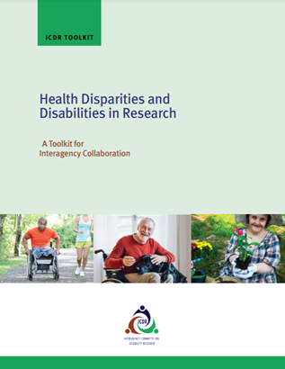
Toolkit on Health Disparities and Disabilities in Research
The ICDR initiated a focus on inclusion of people with disabilities among health and wellness research as well as broader public health programs and initiatives that include people with disabilities as a target population. The purpose of the toolkit on health disparities and disabilities in research is to present resources across federal agencies, federal grantees, and non-federal entities conducting health and wellness research and implementing public health programs and initiatives. This toolkit highlights best practices and effective strategies for including people with disabilities as a priority audience or target population. It features existing resources and programs as they relate to each topic area in order to help address the existing disparities and presents areas for future research related to health disparities and people with disabilities. It is meant to help facilitate further research and collaboration by federal agencies and departments around the health disparities of people with disabilities. It also pulls together identified best practices and effective strategies for disability inclusion for researchers and the public to address these health disparities. The toolkit is posted on the ICDR website at this link: https://icdr.acl.gov/resources/reports/health-disparities-and-disabilities-research.

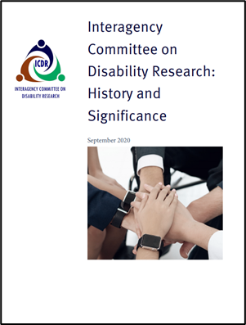
ICDR History and Significance White Paper and Timeline
The ICDR mission is to promote coordination and collaboration among federal departments and agencies conducting disability, independent living (IL), and rehabilitation research programs, including programs related to AT research and research that incorporates the principles of UD. This resource highlights the importance of the ICDR’s role within the disability community, the ICDR’s achievements, and a future outlook. The ICDR timeline highlights the ICDR’s activities, accomplishments, and events from 1978 through the present. It includes topics of accessibility, health disparities, employment, stakeholder input, among others.
The white paper is posted on the ICDR website at this link: https://icdr.acl.gov/resources/reports/interagency-committee-disability-research-history-and-significance.
The timeline is posted to the ICDR website at this link: https://icdr.acl.gov/resources/reports/interagency-committee-disability-research-icdr-timeline.

ICDR Website Enhancements
During FY 2020, the ICDR made a number of website enhancements to the ICDR website (ICDR.acl.gov). These enhancements aimed to better foster collaboration and motivate committee users to routinely use the website and its features as well as encourage interest among public users with engaging and relevant content.
ICDR agency activity profiles were added to the website. These profiles include all member agencies, their mission, news and highlights, agency strategic plans, events, and a link to their website. The ICDR home page was also updated to display the logos of all the member agencies. Users can select these logos to be directed to the new ICDR agency activity profiles.
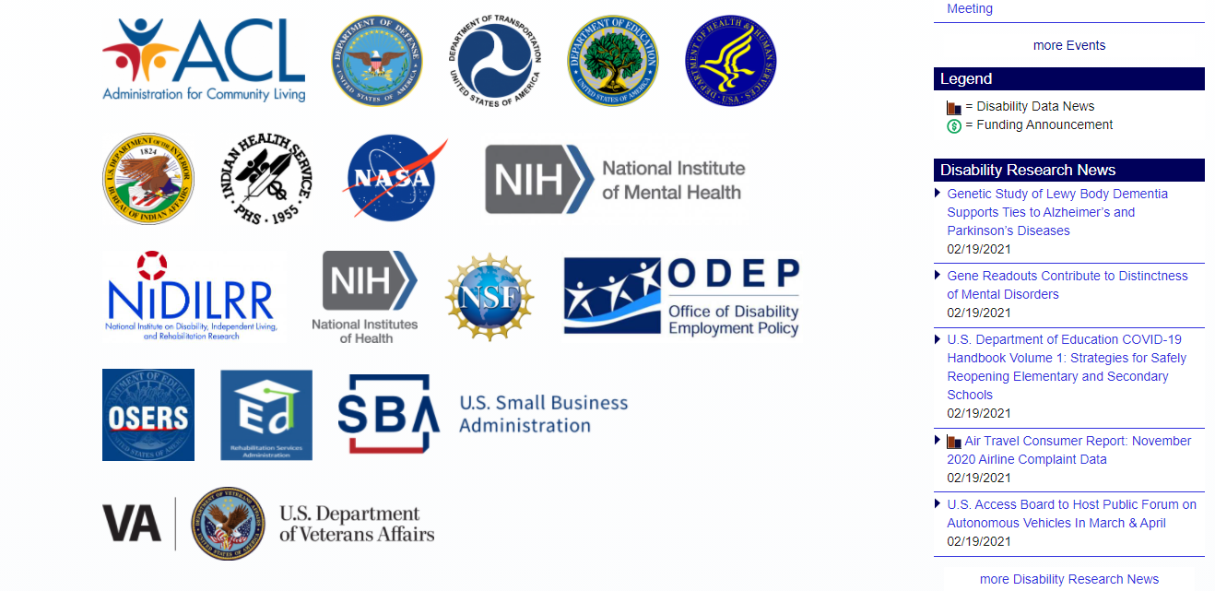
Another website enhancement expanded the existing “Info Share” feature. The enhancement allows users to submit events to be included on the ICDR Events page to help increase cross-collaboration. The leadership and membership of the ICDR are tremendous sources of information, and both the members and the public benefit from this more effective way to collect and share their combined knowledge. The ICDR Events feature was updated to highlight member agency events in addition to ICDR events.
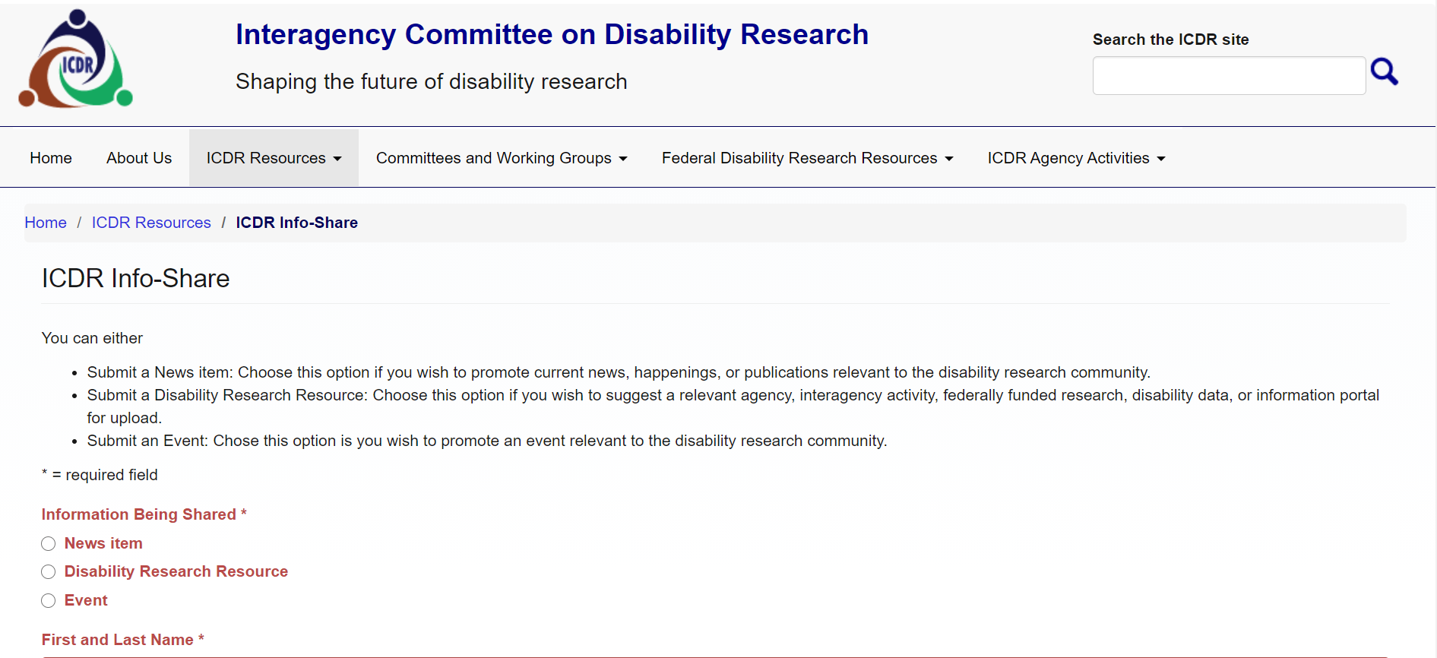
The calendar functionality was enhanced to allow users to see events in a month, week, day, and year view, in addition to a list format. Users can navigate through these calendar views to find events of interest. Users can also filter events by specific member agencies to narrow their events search. The ICDR continues to take recommendations from the ICDR EC and stakeholders to ensure the website fits theirs needs and to continuously improve the site to meet the functional needs of its users.
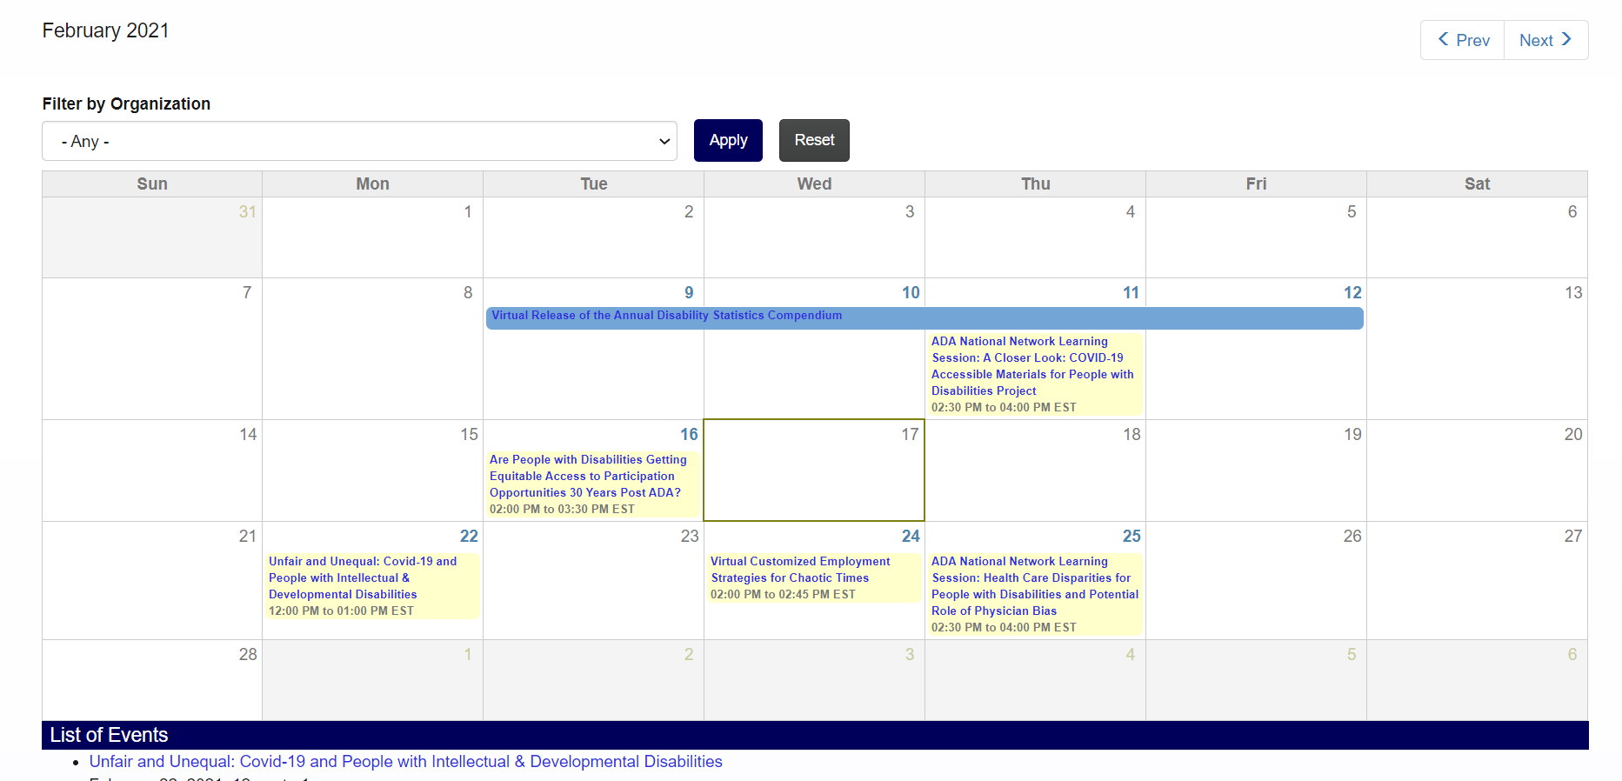

Executive Committee Meetings
The EC met four times in FY 2020 (January, April, June, September). At each of these meetings, members shared agency updates, information on upcoming initiatives, activities, and events. Working group chairs shared progress on the implementation of the strategic plan, including the continued development and launch of the GWI was a priority throughout the year. The committee continued to work together to identify opportunities for future partnerships and collaboration. The second half of FY 2020 focused on the impacts of COVID-19 on Federal Disability Research for member agencies. EC Meeting summaries and any supplemental materials can be found on the Executive Committee page on the ICDR website.

Upcoming Activities in FY 2021
In FY 2020, the ICDR began planning new interagency resources for release in FY 2021, including a white paper and additional toolkits on federal disability research areas. Additionally, the ICDR continued developing a transition symposium that will be held virtually in FY 2021.

COVID-19 White Paper
The COVID-19 pandemic has had a significant impact on disability research across the federal government. Shutdowns across the country to slow the spread of the disease caused research and development institutions to suspend their research and attempt to transition as many projects as possible to a virtual format. While most studies resumed by summer 2020, including some essential in-person research, many projects experienced significant impacts to finances, quality and efficiency, knowledge dissemination, disparities for researchers, and topics of research. COVID-19 has significantly affected research productivity, with an estimated loss in federal research output between 20 to 40 percent (Council on Governmental Relations, 2020). The ICDR developed a white paper that explores the impact of COVID-19 on disability research, to include changes in research design, increased reliance on technology, emerging topic areas, and areas for further research. The goal of this paper is to explore areas where the field of disability research can examine the impact of COVID-19 on people with disabilities and develop unique solutions to the increasing challenges and widening disparities this population is facing.

Additional Toolkits
The ICDR developed two additional toolkits during FY 2020 that will be released in FY 2021 on the ICDR website. The first toolkit centers on federal research and resources related to assistive technology and universal design (AT/UD). While the government continues to engage in ADA implementation and enforcement activities, there remain significant access gaps for people with disabilities across a variety of realms: the physical environment, education, health care, technology, employment, transportation, and housing, among other areas. AT/UD are two areas of disability research that have the potential to significantly improve accessibility across society for people with disabilities. This toolkit will provide an overview of relevant legislation and recent federal research and resources on assistive technology and universal design and provide tools for engaging in future research.
The second toolkit focuses on access to health information technology (HIT) for people with disabilities. The Affordable Care Act spurred development of patient-centered HIT. Considering people with disabilities and older adults in the development of HIT systems could significantly impact the effectiveness and adoption of these systems by people who could benefit the most from them. However, many health IT systems, including mobile “apps,” EHRs, PHRs, telehealth, and kiosks are often not accessible or usable. This toolkit will offer research and resources across the federal government on how to improve access to HIT for people with disabilities. It is imperative that research-based information about accessibility and usability standards be made readily available to encourage accessible design of health IT systems and to ensure people with disabilities and older adults are not excluded.

Virtual Transition Symposium
During FY 2020, the EE Working Group continued planning a virtual symposium on evidence-based transition strategies called Employment for Youth with Disabilities: Translating Evidence Amid Crisis. The group gathered input on possible experts in the field to present and discussed the meeting timeline, format, and vision for the proposed meeting. The virtual symposium will be held in FY21. The goal is for participants to better understand impacts of COVID-19 on youth with disabilities and their families, gain knowledge of current education and employment research, discuss challenges and strategies to promote resiliency and improved employment outcomes. Recommendations for future research, policy and practice will be generated by meeting participants.

